**Safety Recall Notice**

**Vitamix® Ascent® and Venturist® Series**

**8-Ounce Blending Bowls, 20-Ounce Blending Cups & Blade Bases**

The containers may separate from the blade base, exposing the blades to consumers and creating a laceration hazard.

[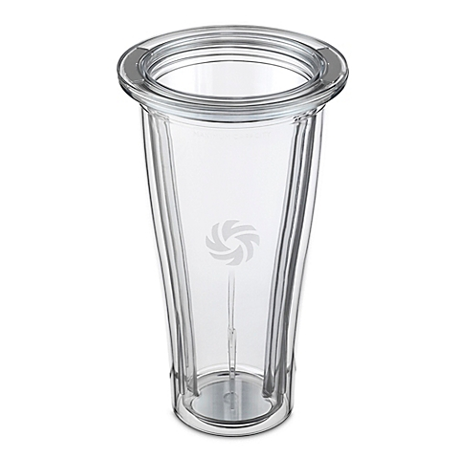](https://s7d1.scene7.com/is/image/BedBathandBeyond/126010061810808p__1?hei=2000&wid=2000&qlt=50,1)

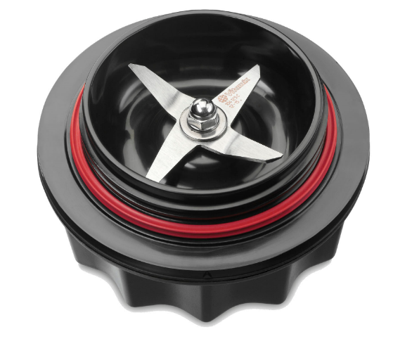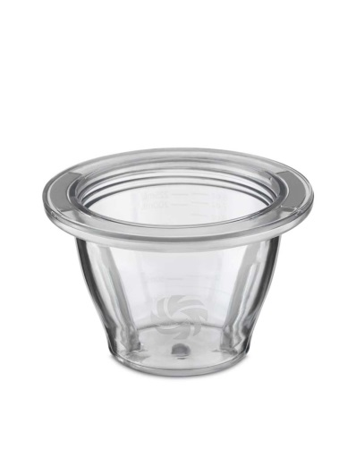

If your product is included,

**STOP USING IT IMMEDIATELY** and visit **BlendingCupBowlRecall.expertinquiry.com**

for information on a free repair kit.

Or call Vitamix toll-free at

**855-215-5178**

Between 7:00 a.m. and 4:00 p.m., Central Time,

Monday through Friday.