Kitchen Newsletter
Target Date: 11-21-17
Title: Pumpkin Cream Cheese Muffins

Resources for Other Photos:
http://www.acornadvisors.com/KitchenArt/Finished_Newsletters/KART_Muffins.html

Constant Contact Name:

November 21, 2017 – Pumpkin Cream Cheese Muffins

Subject Line:
Yes! Pumpkin Cream Cheese Muffins

Teaser Line:

The perfect morning menu for this Thanksgiving weekend!

Facebook and/or Twitter Words:

Put these muffins on the morning menu this week! Not too sweet, but just right. There’s so much pumpkin in these muffins that we’re sure they count as a serving of vegetables! Recipe and tips in our latest newsletter: <link>

In This Issue:

RECIPE: Pumpkin Cream Cheese Muffins

INTRO

“Pumpkin Cream Cheese Muffins”

IMG

INTRO TEXT

IN THIS ISSUE, we’re sharing a fall favorite of ours that we look forward to making (and eating!) whenever autumn rolls around. These muffins satisfy any craving for pumpkin spice and quell any hunger. Put these crowd-pleasing muffins on the menu for breakfast sometime during the long Thanksgiving weekend ahead.

Thumbnails
“”

MAIN BODY:

Pumpkin Cream Cheese Muffins
The best part about these muffins is that they aren’t too sweet, but full of rich fall flavors with just the right amount of spices. Follow these tips, and making these muffins will be quick and easy. You’ll receive well-deserved kudos. But, a warning, we’re pretty sure there will be no leftovers.

[These tips can be broken up throughout the issue or placed en masse elsewhere – doesn’t have to be in this position.]

Muffin Making Tips

Success Tip #1: Mix the muffin batter correctly.
How the muffin batter is mixed has a direct effect on the outcome. Like many quick breads, it’s important to not over mix the batter; doing so destroys the air bubbles that form when the leaveners, (baking powder in this case), are moistened. In general, mix the dry ingredients together; mix the liquid ingredients together, then combine the two.
Success Tip #2: Bake at the right temperature.
Follow the recommended temperature found in the muffin recipe. Generally, a temperature range of 375 – 400°F allows the outside of the muffin to bake while the inside rises into the preferable dome shape of the ideal muffin.
Success Tip #3: Use a nonstick muffin pan.
Removing baked muffins from the baking pan can be tricky. Make it easy by using a nonstick muffin tin. Or, use paper liners to line each cup. If you have neither, grease each cup well prior to adding the muffin batter.
Success Tip #4: Cool in two steps.
Like cookies, muffins straight from the oven can be tender and fragile. Allow them to cool in the pan for a few minutes before removing – but only a few minutes. This allows the muffins to release extra steam and the outsides to set up in the process. Secondly, remove the muffins from the pan and place on a cooling rack. Using a cooling rack allows for air circulation all around the muffin and prevents condensation from forming on the bottom of the muffin.

Success Tip #5: Determining doneness.
A common muffin fail lies with over-baking. No one wants a gooey, under baked muffin, but a dry, crusty muffin is unsalvageable. Using a light fingertip touch, press the top of the muffin (the pumpkin part, not the cream cheese part); the top should spring back when done. If an impression is left, bake longer. Or, using a toothpick, insert into the center of the muffin. The toothpick should be clean when removed, or with just a few moist crumbs. If batter shows on the toothpick, bake longer.
Muffin Batter Ingredients:
2 cups all-purpose flour
3/4 teaspoon cinnamon
1/4 teaspoon ground nutmeg
1/4 teaspoon ground ginger
1-1/2 teaspoons Kosher salt
1-1/2 teaspoon baking powder
1/2 cup melted unsalted butter, cooled slightly
3 large eggs
1-1/2 cups canned pumpkin puree (1 can, 15-oz.)
2 teaspoons vanilla extract
1-1/2 cups sugar
Cream Cheese Filling Ingredients:
8 ounces cream cheese, softened
1/2 cup powdered sugar
1 teaspoon vanilla
2 tablespoons pumpkin seeds or chopped pecans (optional)

Directions:
1. Preheat the oven to 375°F. Lightly grease each well of a 12-cup muffin pan, or line each well with a cupcake liner. Set aside.

2. In a medium bowl, mix together the dry ingredients, (flour, spices, salt, and baking powder). In a larger bowl, mix together the liquid ingredients, (melted butter, eggs, pumpkin, and vanilla). Add the sugar and whisk to combine evenly.

3. Mix the cream cheese filling by combining the cream cheese, powdered sugar, and vanilla with in a small bowl with a hand mixer. Set aside.

4. Mix the muffin batter by adding the dry ingredients to the wet ingredients and stir until just combined; do not over mix. Spoon the batter into the prepared muffin tins evenly distributing the batter. With a spoon, make a slight well in the center of the batter in each cup. Add a spoonful of the cream cheese filling on top of each muffin. (Serve any leftover filling on the side when serving the hot muffins or save for a sweet topping on toasted bagels.) It will sink somewhat during baking and the muffin will rise and bake around the center of the filling. Top each muffin with a few pumpkin seeds or chopped pecans, if desired.

5. Bake for 16-18 minutes or until the muffin portion (not the filling) springs back from a finger touch, or until a toothpick in the muffin portion returns cleanly. Cool the muffins in the pan for 3-4 minutes before removing from the pan, then remove and place on cooling rack to finishing cooling, (or eat while still warm!).

Improvisations:

Variation #1: Make miniature versions.
These Pumpkin Cream Cheese muffins adapt well to miniature versions. Use a nonstick pan that makes 24 mini muffins at a time. These are the perfect size for when just a snack is desired.
Variation #2: Pre-mix the muffin dry ingredients.
Make life easy by pre-mixing a couple of batches of dry ingredients ahead of time and storing in a zipper plastic bag, or other airtight container. Include a card with the recipe inside to note the remaining ingredients and baking time and temperatures. Half the mixing work is done with this do-ahead tip. Or, mix the dry and liquid mixtures the evening before keeping separate and the liquid portion refrigerated. Warm the liquid mixture to just room temperature, then finish mixing the batter.

Variation #3: Add chocolate chips to the muffin batter for an extra special muffin experience. Or, if you’re a nut fan, add your favorite chopped nuts to the batter.

Variation #4: Make a batch of these muffins, cool completely, then wrap individually and place in the freezer. They will be a great “grab-n-go” breakfast on a busy day.

Cooking Tools:

USA Pans Muffin Pan
(include a star/balloon – “our hands-down favorite”)

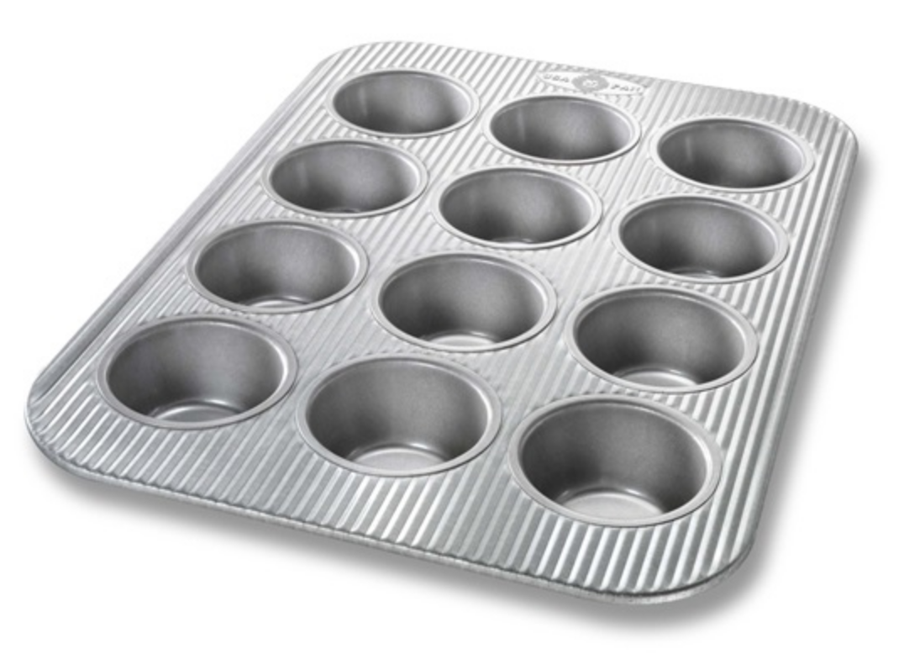

A quality muffin pan is key to a successful outcome! Choose a muffin pan that:
- features a nonstick baking surface
- uses quality materials that will not warp when heated
- cleans easily – you’ll make muffins more often if it’s easy
- transfers safely in and out of the oven with broad edges for easy gripping

