Kitchen Newsletter
Target Date: 01-19-17
Title: Making Yogurt
Constant Contact Name:

January 19, 2017 – Making Homemade Yogurt

Subject Line:
Make Your Own Yogurt at Home!

Teaser Line:

More delicious, less expensive!

Facebook and/or Twitter Words:

If you haven’t tried making your own yogurt before, now’s the time! Save money (one-fifth the cost), control the amount of sweeteners, and enjoy the health benefits! We teach you how easy it is in our latest newsletter: <link>

Homemade yogurt is easier than you think to make – just two ingredients! Find out the simple steps in our latest newsletter: <link>

Yogurt is a popular, everyday food, but just how much do you know about it? Would you like to make you own? Find out how and some out-of-the-norm recipes in our latest newsletter: <link>

In This Issue:

What is Yogurt?
Why Make Your Own?
RECIPE: Basic Yogurt – a How-to
Yogurt-Making Tips
Variations on the Basics
Gadgets for Fermenting
RECIPE: Yogurt-Chia Seed Yogurt
RECIPE: Labneh with Toast and Tomatoes
FAQ’s About Yogurt

INTRO

“Make Your Own Yogurt at Home”

IMG

INTRO TEXT

Eating yogurt is an everyday event for many of us. It’s a nutritious, satisfying choice for a quick meal or a snack. If you haven’t tried making your own yogurt before, now’s the time! Save money, control the amount of sweeteners, and enjoy the health benefits!

IN THIS ISSUE, we teach you the 1-2-3 for making your own yogurt. Plus, a couple of new ways to enjoy yogurt, one sweet, the other savory.

Thumbnails
Basic Yogurt - Yogurt-Chia Pudding - Labneh on Toast with Tomatoes

MAIN BODY:

What is Yogurt?

Yogurt is hardly a new thing. It’s an ancient food, some say dating back to 5000 B.C.E in Mesopotamia, but popular in America just in the last several decades. As with the ancient cultures where yogurt has had a long history, it’s now a standard part of everyday life for young and old. Yogurt is fermented milk (cow, goat, sheep, or other) thanks to heat-loving and lactose-loving bacteria including one or more of the following species: Lactobacillus delbrueckii bulgaricus, Streptococcus thermophilus, Bifidobaterifum lactis, Lactobacillus acidophilus, or others.

Popular of late, are Greek-style yogurts which are nothing more than regular yogurt that has been strained to remove some of the yogurt’s water concentrating and thickening the yogurt in the process. Icelandic versions (skyr) are also popular and similarly thick in nature. Swiss versions feature fruit on the bottom. Kefir, sometimes known as “drinkable yogurt,” is related and made like yogurt, but features different bacterial cultures plus a yeast component.

Why Make Your Own?
While easily available at grocers (and even convenience gas stations), making your own yogurt has many benefits:

- Yogurt is nutritionally dense providing about 20-30% of a day’s protein requirements, calcium aplenty in a very absorbable form, and many vitamins and micronutrients thanks to its fermented origins.
- Making your own yogurt allows better management of the additions, particularly sweeteners. At one point in yogurt’s recent domestic history, more than half the calories came from sugar. Of late, the pendulum has moved back to yogurt’s origins with less adulterated versions now more desirable.
- Homemade yogurt is less expensive. A quart of milk costs about $1.20 and makes 32 oz. of yogurt. In contrast, individual cups of yogurt cost about 5 times more (6 oz. of yogurt at a cost $1.20 each, or $6.00 for the same total amount of yogurt).

How to Make Yogurt at Home – Basic Yogurt Recipe
Making your own yogurt couldn’t be easier! Just two ingredients, and time makes it happen. Start with a quart of milk, and 4-6 oz. plain yogurt (marked as having “active cultures”). Keep at a warm temperature for 8-12 hours and delicious yogurt will meet you on the other side. The active cultures in the starter yogurt multiply during the incubation period transforming the milk (skim, 2%, or whole) into thick, tangy yogurt. From this basic recipe for yogurt, so many serving presentations and other recipes are possible. Master this fermentation process and you’ll be healthy, wealthy, and wise!

Stovetop Pot Method:
IMG 5534 | IMG 5557 | IMG 5537
Pour one quart of milk into a 2-3 quart enameled cast iron pot. | Cover and bring the milk to 180°F – just short of a boil. | Hold this temperature for 10 minutes. Remove any skin that might have formed.
IMG 5571 | IMG 5584 | IMG 5596
Allow the milk to cool to 110°F – the optimal fermenting temperature. | Temper the plain starter yogurt by drizzling and whisking in1/2 cup of the warm milk. Repeat 3 more times. | Add the tempered starter yogurt to the pot with milk. Whisk together.
IMG 5615 | IMG 5635 | IMG 5892
Cover and keep the pot warm for 8-12 hours. | Wrap the pot in a towel to insulate and retain the warmth. (See tips below.) | Transfer the completed yogurt to the refrigerator. Chill, and enjoy!

Yogurt Machine Method:
IMG 5490 | IMG 5511 | IMG 5515
Start with 1 quart of milk and 4-6 oz. plain yogurt with active cultures. | Whisk the milk and yogurt together. | Pour the mixture in the yogurt machine. Set the timer for 8-12 hours.

Yogurt-Making Tips:
(1) The first step of boiling the milk eliminates any bacteria present in the milk that might otherwise compete with yogurt culture development. This is less of an issue now than in the past when using fresh, pasteurized, store-bought milk.
(2) When choosing the starter culture, choose any plain yogurt where the package indicates “active cultures.” Some packaging will specify the particular strains of the good bacteria. Try different starter yogurts and see what you prefer the best.

(3) Tempering the starter culture with warm milk gradually shifts the temperature of the yogurt and prevents shocking the live organisms.

(4) To keep the milk mixture warm during fermentation start with an enameled cast iron pot or stoneware pot that provides natural insulation and temperature retention needed. Choose one of these methods for retaining heat and promoting fermentation:
- Place the pot in the oven of a gas oven; the pilot light will promote an ideal environment.
Wrap the pot in a towel and place in an electric or gas oven that’s “off.”
- Place the wrapped pot in a microwave oven and leave undisturbed for the fermentation period.
- Fill a hot water bottle and place in a picnic cooler with the pot, close tightly for 8-12 hours.

Variations on the Basics
With basic yogurt mastered, there are a host of uses available.

- Enjoy the yogurt by topping with fresh fruit, jam, granola, nuts, coconut, chocolate bits, or favorite items of your choice.
- Don’t forget to try savory uses of yogurt such as in Tzatziki Sauce (cucumbers, garlic and yogurt), Raita (cucumbers, cumin, curry and yogurt), or yogurt marinades so popular in Indian cuisine. Serve yogurt alongside spicy foods – it’s the perfect antidote to chill the heat.
- Yogurt provides an excellent, lower calorie substitute for sour cream or cream cheese (see the recipe for Labneh below).

Gadgets for Fermenting:

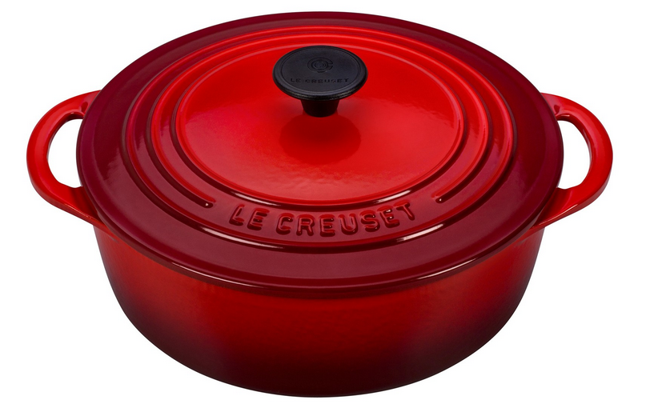 | 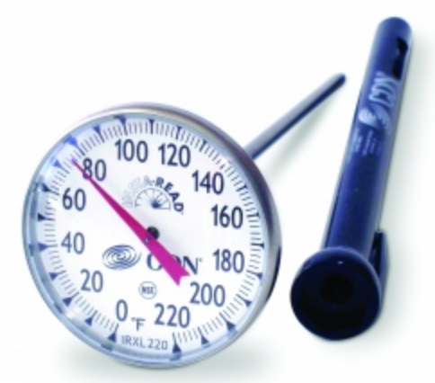 | 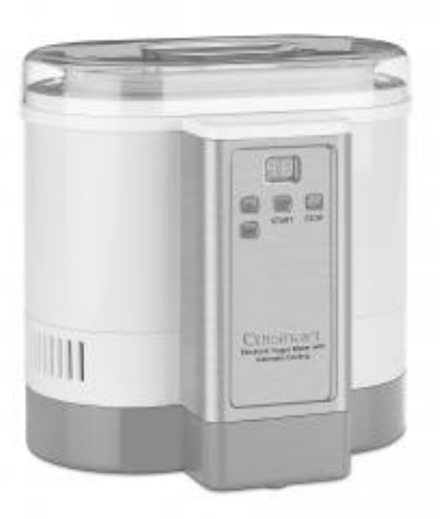
LE CREUSET  2.75 QT. SHALLOW  ROUND OVEN | CDN LARGE DIAL THERMOMETER | CUISINART  YOGURT MAKER
The perfect pot for fermenting yogurt! Non-reactive, enameled cast iron holds the warm temperatures steady. | Using accurate temperature readings to manage the process is key to success. | This yogurt maker features steady warm temperatures for fermenting and a chilling feature!
 | 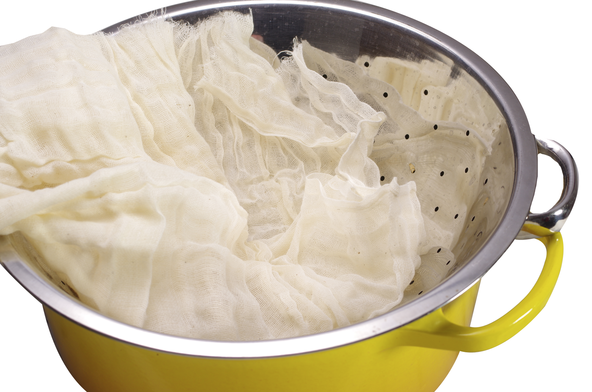 | 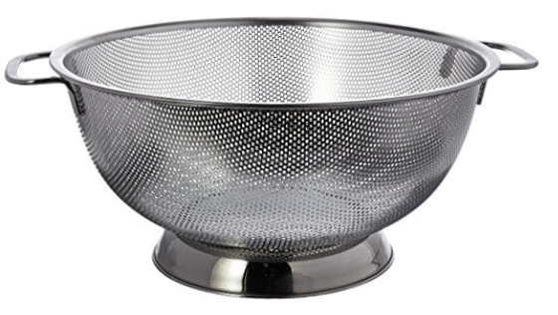
WHISK | CHEESECLOTH | RSVP LARGE COLANDER
A kitchen essential with wonderful mixing powers. Keep a couple sizes handy. | Not fancy or glitzy, but so handy for many kitchen tasks. Use to strain yogurt. | This colander features generous piercings for effective draining whenever it’s used.
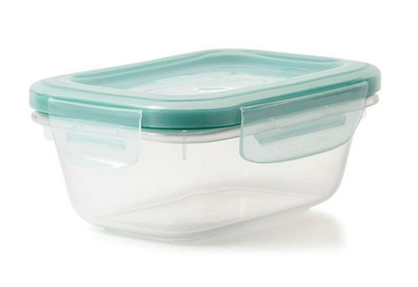
OXO GOOD GRIPS
SNAP CONTAINERS
Keep a supply of containers for refrigerator storage or for food-on-the-go. BPA-free lids snap on glass containers.

Yogurt-Chia Seed Pudding
As if yogurt couldn’t get any healthier, the addition of chia seeds does just that! With an overnight soak in yogurt, the little seeds swell to tenderness and naturally thicken the yogurt. Chia seeds are low in calories (60 calories/tablespoon) and high in nutrition as a potent antioxidant, fiber source, and a great source of Omega 3 fatty acids. The result of this pairing is an ultra-nutritious breakfast that’s very satisfying. Dressed with a few toppings it makes a great everyday dessert, too.

Chia seed image – IMG 6008

Labneh on Toasts with Tomatoes

Yogurt has a wonderful savory side that often is ignored. A great example of this is labneh, (pronounced LEB-neigh), a strained version of yogurt that becomes very thick and spreadable with the consistency of cream cheese. Labneh has a lower fat content than cream cheese or sour cream making it an excellent, high protein substitute. In this recipe’s use of labneh, baguettes are toasted, slathered with the ultra-thick yogurt, and topped with quartered tomatoes dressed in a tangy vinaigrette. These layered toasts make a great appetizer, or in larger form, the perfect lunch!
FAQ’s About Yogurt

(1) Q: How do I know when the yogurt is done?
A: When starting with excellent active cultures, the process will take 8-12 hours. The actual length of time will vary based on the starter culture and the temperatures maintained throughout the process. Check for “doneness” by assessing the consistency of the yogurt. When thickened as expected, it is done.

(2) Q: Can yogurt fermentation be overdone?
A: Yes, at some point, the active cultures will expend themselves and no longer produce optimally. If the whey (clear liquid) separates from the yogurt, the yogurt is overdone, but still edible.

(3) Q: What is the best yogurt to use for the starter culture?
A: Any plain yogurt marked with “Active Cultures Present” will work. Many yogurts have other ingredients such as thickeners and stabilizers included. We like to stick with just the basic milk and active culture varieties. Some of our favorite yogurts for culturing are Siggi and Fage – they always seem to produce excellent results.

(4) Q: Do I have to get fresh commercial starter culture each time I make yogurt?
A: No. Save a little yogurt from the previous batch and use it to inoculate the next batch. Over time if the fermenting results diminish, refresh with a new starter culture.

(5) Can I make yogurt with almond milk, other nut milks, or soy?
A: Yes and no. The bacterial cultures used in making dairy-based yogurt are lactose-loving. Because nut milks do not have lactose, the regular dairy yogurt cultures have nothing to feed on. However, cultures for fermenting nut milks are available at many health food markets.

(6) Q: What type of milk is best to use for yogurt-making, skim, 1%, 2%, or whole?
A: Any of these milks may be used with success; though whole milk varieties offer a level of overall satiety that skim milk does not.

(7) Q: What is the watery liquid that’s often on top of yogurt?
A: This is whey. It’s the result of separation in the yogurt. Such separation is not a problem. The liquid may simply be stirred back into the yogurt. Whey is also the watery runoff when straining yogurt when making Greek yogurt or Labneh. Use any captured whey, which is slightly acidic, in baking, making smoothies or as a poaching liquid.

Graphic Footer

Spoon – horizontal with yogurt trail

